NAME: DONEL

SURNAME: NTAMBWE

STUDENT NUMBER: ST10434784

GROUP MEMBERS:

Elton Marumbwa ST10453820

Emmanuel Olafisoye ST10450437

Samuel Mogashoa ST10453678

------------------------------------------------------------------------------------------------------------------

**GitHub Link**

[Donel21/XHAW-GROUP-WORK-POE: this repository consists if all the final poe of XHAW and all the members names](https://github.com/Donel21/XHAW-GROUP-WORK-POE)

**YouTube Link**

[GROUP XHAW POE](https://www.youtube.com/watch?app=desktop&v=c9CpavrqaHc)

[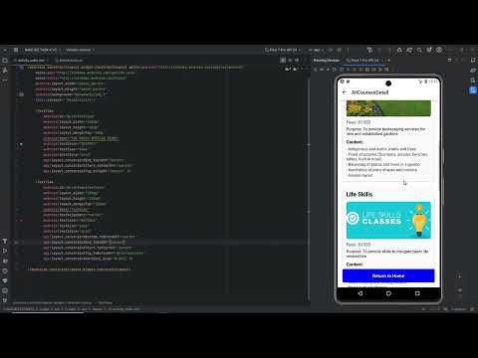](https://www.youtube.com/watch?app=desktop&v=c9CpavrqaHc)

[XHW 511](https://www.youtube.com/watch?v=2HRb7CE9fo0)

[](https://www.youtube.com/watch?v=2HRb7CE9fo0)

**ANNEXURE A**

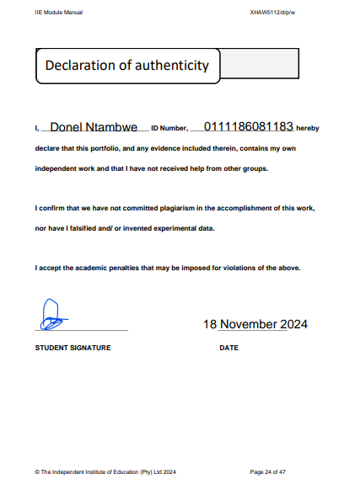

**ANNEXURE B – Peer Evaluation**

